Name: _____________________ Class:__________ Date:__________
Instructions: Circle answers in the answer sheet. Score: ___________ / 61 marks

Multiple Choice Answer Sheet

1. A B C D 15. A B C D
2. A B C D 16. A B C D
3. A B C D 17. A B C D
4. A B C D 18. A B C D
5. A B C D 19. A B C D
6. A B C D 20. A B C D
7. A B C D 21. A B C D
8. A B C D 22. A B C D
9. A B C D
10. A B C D
11. A B C D
12. A B C D
13. A B C D
14. A B C D

Section A— Multiple choice (22 marks)

Which of the following is neutral, without any charge?
- electron
- nucleus
- atom
- ion
An electric circuit is best described as:
A a path taken by electricity.
B the flow of electricity.
C something which will not conduct electricity.
D the force pushing electricity through a conductor.

The unit used to measure electric current is:
- amperes
- volts
- ohms
- ammeter
The instrument used to measure voltage is called:
- an ammeter
- a battery
- a voltmeter
- a series circuit
Daniel and David rubbed a perspex rod with a piece of cloth and observed that the cloth became positively charged. As a result of this, the perspex rod:
A became positively charged.
B became quite warm.
C became negatively charged.
D remained neutral.

Two light globes are attached in parallel with a battery. Another light globe is attached in parallel to the first two. What would happen to the brightness of the first two globes?
- They get duller.
- They get brighter.
- They stay the same brightness.
- They would all ‘blow’.
A transformer:
- increases or decreases voltage
- is a safety device that cuts the current if too much is flowing
- is a machine that turns into a robot
- is a power pack
The resistance of a wire does NOT depend on the:
- type of material the wire is made from
- length
- thickness of the wire
- voltage applied across the wire
Which of the following materials is an insulator?
- copper
- nichrome
- rubber
- aluminium
10 | Blair rubbed a perspex rod with a piece of cloth and observed that the cloth became positively charged. What has been transferred from the rod to the material to cause this change?  A electrons.  B protons.  C neutrons.  D perspex molecules.
11 | The colour of the active wire in an electrical cable is:  - blue  - brown  - green and yellow  - black

12 | The following circuit diagram should be used to answer questions 12 to 17.  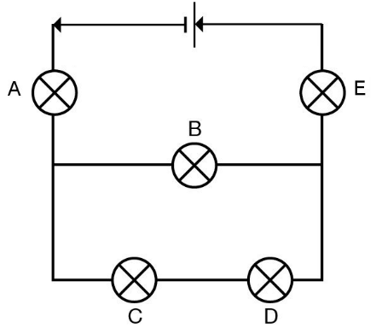  A switch is to be inserted into the circuit below so that it turns on and off ALL the globes at once. Where should the switch be placed?  - next to globe A  - immediately to the left of globe B  - immediately to the right of globe B  - between globes C and D
13 | An ammeter is to be placed in the circuit above so that it measures the total current flowing in and out of the battery. How and where should the ammeter be connected?  - in series between globes C and D  - in parallel, piggy-backing globe A  - in series, next to globe E  - in parallel, piggy-backing globe B
A voltmeter is to be placed in the circuit above so that it measures the total voltage supplied by the battery. How and where should the voltmeter be connected?
- in parallel, piggy-backing globe B
- in parallel, piggy-backing globe A
- in series, between globes C and D
- in series, next to the battery
All globes in the circuit above were working correctly when globe A broke and stopped glowing. Which of the other globes would also have stopped glowing because of this?
- all globes
- only globe E
- only globe B
- only globe C
Globe A was then replaced so that all globes in the circuit above were once again working. Soon after, globe C broke and stopped glowing. Which of the other globes would also stop glowing because of this?
- all globes
- only globe D
- only globe A
- only globe E
When globe C broke in the circuit above, what would have happened to globe B?
- Globe B would stop glowing.
- Globe B would glow brighter.
- Globe B would glow less brightly.
- Globe B would glow exactly the same as before.
An electrical insulator is best described as:
A a path taken by electricity.
B the flow of electricity.
C something which will not conduct electricity.
D the force pushing electricity through a conductor.
Use the following information to answer questions 19 to 22.
A light globe was connected into the circuit below. The current passing through it was measured as the voltage of the power pack was increased.
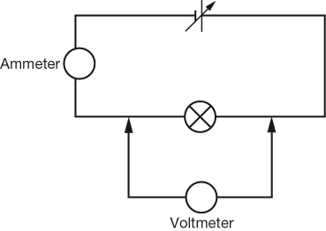
The results of the experiment are shown in the graph below.
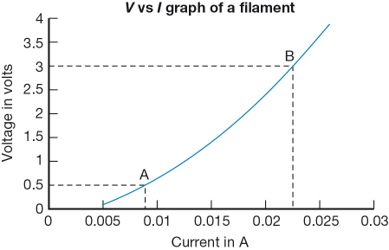
State the approximate current flowing through the globe when 2.5 V is applied across it.
- 0.02 A
- A
- 0.025 A
- 0.005 A
Approximately what voltage causes a current of approximately 0.023 A to pass through it?
- 3 V
- 0.5 V
- 4 V
- 1 V
The current was not measured when the voltage was zero. Use the graph to predict the current when the battery is disconnected.
- 0 A
- 0.002 A
- 0.004 A
- 0.005 A
The resistance of the graph can be predicted from the slope of the graph. The steeper the graph, the higher the resistance of the light globe. Use the graph to determine which of the following statements is most accurate.
- Resistance is constant.
- Resistance increases as voltage increases.
- Resistance decreases as voltage increases.
- Resistance is zero because the wire in a light globe is a conductor.

Section B— Short answer (39 marks)
Contrast static electricity with current electricity.(add diagrams)
Static electricity ________________________________________________________________________________________________________________________________________
____________________________________________________________________

Current Electricity ____________________________________________________________________________________________________________________________________________________________________________________________________________

(4 marks)
a What is the voltage available from power points.
_______________________________________________________________

b State whether power points supply AC or DC electricity.
______________________________________________________________

c Some power points have a small blue switch on them. Explain what it is for.
_____________________________________________________________
_____________________________________________________________
_____________________________________________________________
_____________________________________________________________
(4 marks)

Work out the supply voltage of the battery arrangement shown below.

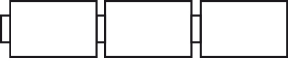
6 V 6V 6V

Supply voltage: _________________________
(1 mark)
List three advantages that parallel circuits have over series circuits.

Advantages of Parallel Circuits Compared to Series Circuit
(3 marks)
Use words from the diagram below to complete the sentences.
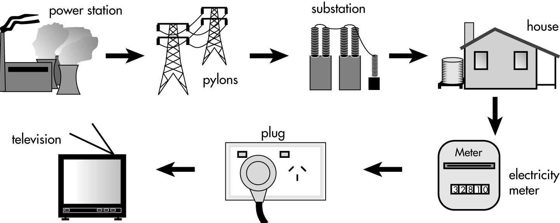
a Electricity is generated in a ___________ ___________.
b It is carried in big wires or cables. ___________ hold the cables above the ground.
c Sometimes the cables are buried in the ground. The electricity always goes to a ___________ before it reaches our homes. An ___________ ___________ outside the house measures how much electricity we use.
(4 marks)
Casey, Bella and Luke created this circuit
Use their diagram to answer Question 6
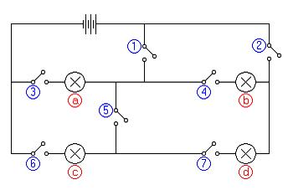
If only switches 2, 3 and 4 are closed, which bulbs will glow?
_____________________________________________________________________________________________________________________________________________________________________________________________________________________
(2 marks)
If only bulb ‘c’ glows, which switches would be closed?
____________________________________________________________________________________________________________________________________________________________________________________________________________________________________________________________________________________________
(2 marks)
Which two bulbs are in parallel?
__________________________ _________________________________
(2 marks)
The switches are set up so that either bulbs ‘a’ and ‘b’ are glowing or ‘a’ and ‘c’ are glowing.
If you compared the brightness of bulb ‘a’ when it was on with ‘c’ to when it was on with ‘b’, you would expect it to be:. Describe why?
__________________________________________________________________________________________________________________________________________________________________________________________________________________________________________________________________________________________________________________________________________________________________________________________________________________________________________
(3 marks)
Jasmine, Zoe and Jacob ran a series of tests on the voltage obtained when torch batteries were connected in various ways. Their results are shown below.
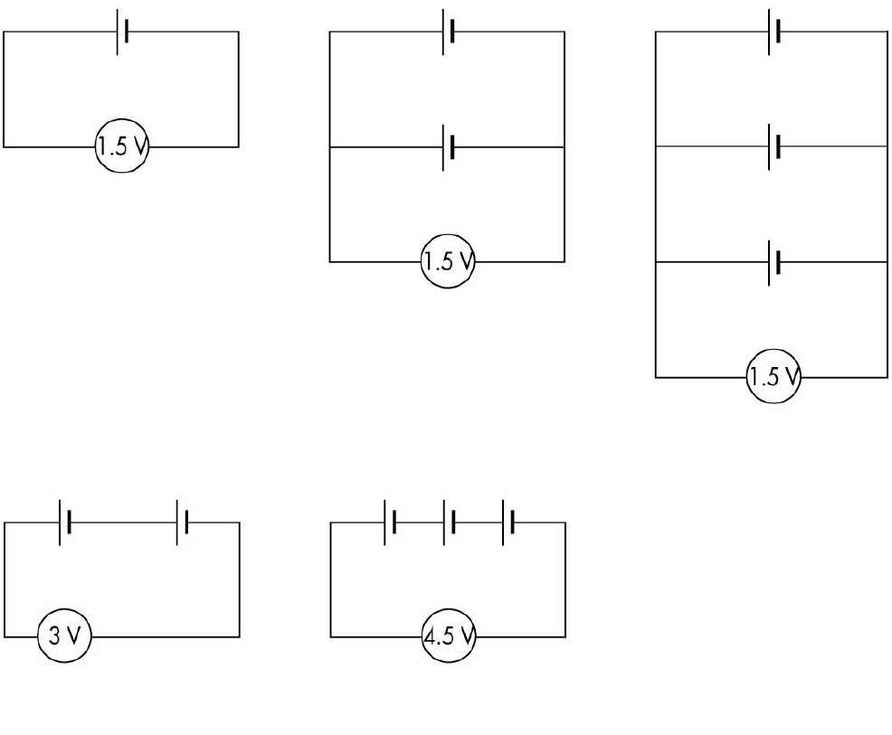
a Zoe, Jacob and Jasmine have four cells (1.5 V each) and wishes to obtain a 6 V output. How should they connect the cells?
______________________________________________________________________
______________________________________________________________________
(4 marks)
DRAW THE SET UP AS CIRCUIT DIAGRAM

b If Jasmine had to use five cells (1.5 V each) and still obtain an output of 6 V, suggest a way of connecting the cells.
______________________________________________________________________
______________________________________________________________________
(4 marks)
DRAW THE SET UP AS CIRCUIT DIAGRAM

Andy and Oliver set up the following circuits
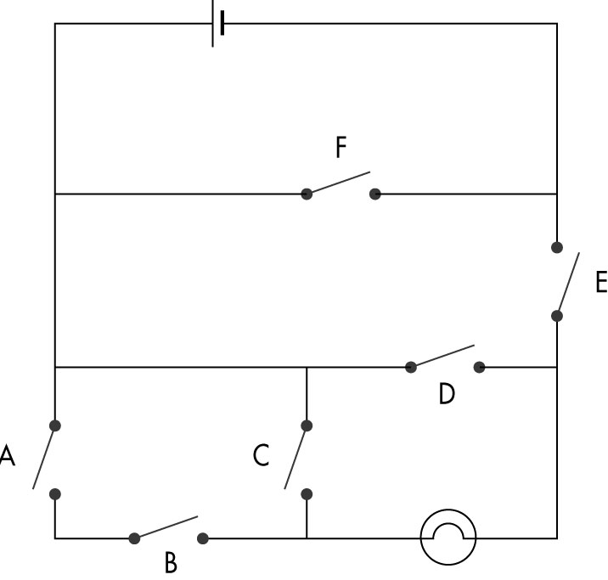
a Will the globe light with the circuit as shown?________________________ (1 mark)
b What is the fewest number of switches that have to be closed to make the light come on? Which switches are they? ______________________________________________________________________________________________________________________________________________
(2 marks)

c If switches A, B and E are closed, the light comes on. What happens if you then switch D on?
______________________________________________________________________
______________________________________________________________________
(2 marks)
Try to explain your result from part c.
____________________________________________________________________________________________________________________________________________
(1 mark)

